ASSIGNMENT ON CLUSTERING

1. Perform Clustering for the crime data and identify the number of clusters formed and draw inferences.

Data Description:

Murder -- Murder rates in different places of United States

Assault- Assault rate in different places of United States

UrbanPop - urban population in different places of United States

Rape - Rape rate in different places of United States

Ans:

normalizing <- scale(crime_data[,2:5])

distance <- dist(normalizing,method="euclidean")

hier <- hclust(distance,method= "complete")

plot(hier)

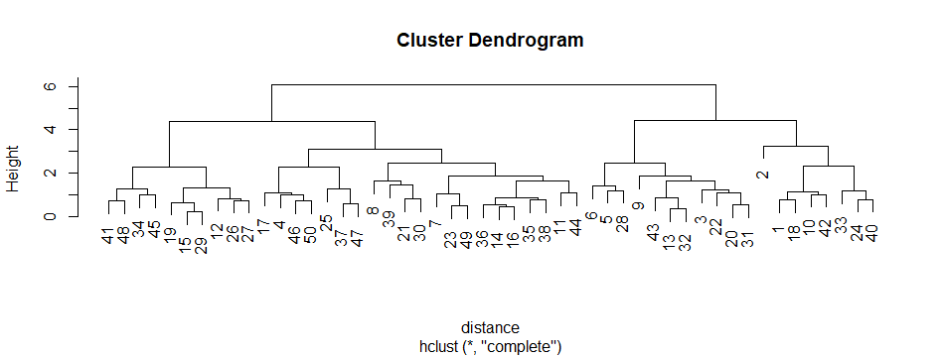

plot(hier,hang = -1)

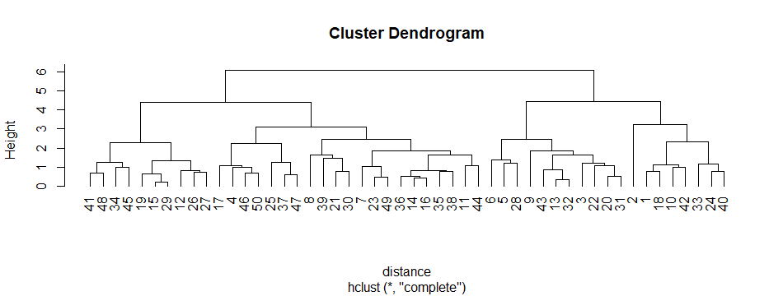

**So there are 4 clusters**.

rect.hclust(hier,k=4, border = "blue")

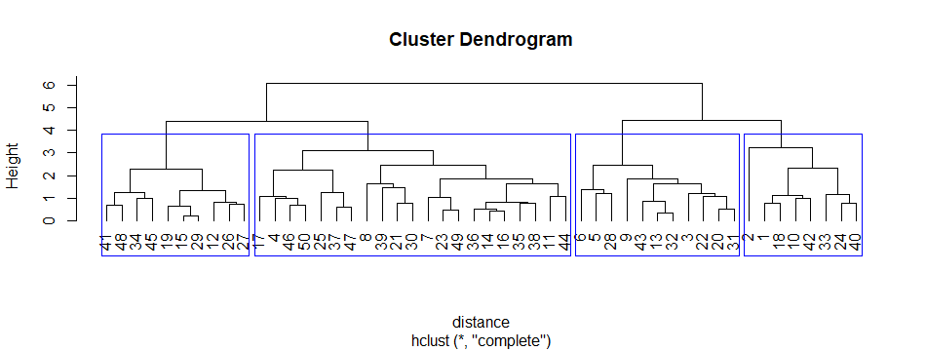

group <- cutree(hier,k=4)

ctmat <- as.matrix(group)

final <- data.frame(crime_data,ctmat)

View(final)

|  | **X1** | **Murder** | **Assault** | **UrbanPop** | **Rape** | **ctmat** |
| --- | --- | --- | --- | --- | --- | --- |
|  |  |  |  |  |  |  |
| 1 | Alabama | 13.2 | 236 | 58 | 21.2 | 1 |
| 2 | Alaska | 10.0 | 263 | 48 | 44.5 | 1 |
| 3 | Arizona | 8.1 | 294 | 80 | 31.0 | 2 |
| 4 | Arkansas | 8.8 | 190 | 50 | 19.5 | 3 |
| 5 | California | 9.0 | 276 | 91 | 40.6 | 2 |
| 6 | Colorado | 7.9 | 204 | 78 | 38.7 | 2 |
| 7 | Connecticut | 3.3 | 110 | 77 | 11.1 | 3 |
| 8 | Delaware | 5.9 | 238 | 72 | 15.8 | 3 |
| 9 | Florida | 15.4 | 335 | 80 | 31.9 | 2 |
| 10 | Georgia | 17.4 | 211 | 60 | 25.8 | 1 |
| 11 | Hawaii | 5.3 | 46 | 83 | 20.2 | 3 |
| 12 | Idaho | 2.6 | 120 | 54 | 14.2 | 4 |
| 13 | Illinois | 10.4 | 249 | 83 | 24.0 | 2 |
| 14 | Indiana | 7.2 | 113 | 65 | 21.0 | 3 |
| 15 | Iowa | 2.2 | 56 | 57 | 11.3 | 4 |
| 16 | Kansas | 6.0 | 115 | 66 | 18.0 | 3 |
| 17 | Kentucky | 9.7 | 109 | 52 | 16.3 | 3 |
| 18 | Louisiana | 15.4 | 249 | 66 | 22.2 | 1 |
| 19 | Maine | 2.1 | 83 | 51 | 7.8 | 4 |
| 20 | Maryland | 11.3 | 300 | 67 | 27.8 | 2 |
| 21 | Massachusetts | 4.4 | 149 | 85 | 16.3 | 3 |
| 22 | Michigan | 12.1 | 255 | 74 | 35.1 | 2 |
| 23 | Minnesota | 2.7 | 72 | 66 | 14.9 | 3 |
| 24 | Mississippi | 16.1 | 259 | 44 | 17.1 | 1 |
| 25 | Missouri | 9.0 | 178 | 70 | 28.2 | 3 |
| 26 | Montana | 6.0 | 109 | 53 | 16.4 | 4 |
| 27 | Nebraska | 4.3 | 102 | 62 | 16.5 | 4 |
| 28 | Nevada | 12.2 | 252 | 81 | 46.0 | 2 |
| 29 | New Hampshire | 2.1 | 57 | 56 | 9.5 | 4 |
| 30 | New Jersey | 7.4 | 159 | 89 | 18.8 | 3 |
| 31 | New Mexico | 11.4 | 285 | 70 | 32.1 | 2 |
| 32 | New York | 11.1 | 254 | 86 | 26.1 | 2 |
| 33 | North Carolina | 13.0 | 337 | 45 | 16.1 | 1 |
| 34 | North Dakota | 0.8 | 45 | 44 | 7.3 | 4 |
| 35 | Ohio | 7.3 | 120 | 75 | 21.4 | 3 |
| 36 | Oklahoma | 6.6 | 151 | 68 | 20.0 | 3 |
| 37 | Oregon | 4.9 | 159 | 67 | 29.3 | 3 |
| 38 | Pennsylvania | 6.3 | 106 | 72 | 14.9 | 3 |
| 39 | Rhode Island | 3.4 | 174 | 87 | 8.3 | 3 |
| 40 | South Carolina | 14.4 | 279 | 48 | 22.5 | 1 |
| 41 | South Dakota | 3.8 | 86 | 45 | 12.8 | 4 |
| 42 | Tennessee | 13.2 | 188 | 59 | 26.9 | 1 |
| 43 | Texas | 12.7 | 201 | 80 | 25.5 | 2 |
| 44 | Utah | 3.2 | 120 | 80 | 22.9 | 3 |
| 45 | Vermont | 2.2 | 48 | 32 | 11.2 | 4 |
| 46 | Virginia | 8.5 | 156 | 63 | 20.7 | 3 |
| 47 | Washington | 4.0 | 145 | 73 | 26.2 | 3 |
| 48 | West Virginia | 5.7 | 81 | 39 | 9.3 | 4 |
| 49 | Wisconsin | 2.6 | 53 | 66 | 10.8 | 3 |
| 50 | Wyoming | 6.8 | 161 | 60 | 15.6 | 3 |

Showing 1 to 12 of 50 entries, 6 total columns

write.csv(final,file="finalcrime.csv",row.names = F)

aggregate(crime_data[,-1],by = list(final$ctmat),mean)

Group.1 Murder Assault UrbanPop Rape

1 1 14.087500 252.7500 53.50000 24.53750

2 2 11.054545 264.0909 79.09091 32.61818

3 3 5.871429 134.4762 70.76190 18.58095

4 4 3.180000 78.7000 49.30000 11.63000

**Inferences:**  So according to the above clustering analysis, we reach out in the following assumptions.

1. According to the crime rate, the regions are classified into 4 classes in decreasing order of rates.
2. In group 1,the crime rates are high( i.e, murder rate, assault rate ,rape rate ) and on going down worth, the rates getting decreases.
3. From the clustering we should conclude that the regions under group 4 are moderately suitable for living than other 3 groups.
4. The crime rate does not depend on urban population rate.
5. Murder rate is much lesser than rape rate in every region.
6. Perform clustering (Both hierarchical and K means clustering) for the airlines data to obtain optimum number of clusters.

Draw the inferences from the clusters obtained.

Ans:

normalizing <- scale(airlines[,2:11])

pkgs <- c("factoextra","NbClust")

install.packages(pkgs)

NbClust::NbClust(airlines, diss = NULL,distance = "euclidean",min.nc = 2,max.nc = 15,method = "complete")

*** : The Hubert index is a graphical method of determining the number of clusters.

In the plot of Hubert index, we seek a significant knee that corresponds to a

significant increase of the value of the measure i.e the significant peak in Hubert

index second differences plot.

*** : The D index is a graphical method of determining the number of clusters.

In the plot of D index, we seek a significant knee (the significant peak in Dindex

second differences plot) that corresponds to a significant increase of the value of

the measure.

*******************************************************************

* Among all indices:

* 6 proposed 2 as the best number of clusters

* 5 proposed 3 as the best number of clusters

* 1 proposed 4 as the best number of clusters

* 1 proposed 5 as the best number of clusters

* 1 proposed 6 as the best number of clusters

* 1 proposed 9 as the best number of clusters

* 8 proposed 10 as the best number of clusters

* 1 proposed 15 as the best number of clusters

***** Conclusion *****

**\* According to the majority rule, the best number of clusters is 10**

*******************************************************************

$All.index

KL CH Hartigan CCC Scott Marriot TrCovW TraceW

2 0.3605 831.1581 1424.9480 -44.2167 23504.01 1.151661e+84 9.258574e+25 3.557048e+13

3 6.6239 1275.8895 33.3217 -88.2657 24971.10 1.795479e+84 4.838367e+25 2.622217e+13

4 0.0912 868.5757 3228.6982 -196.6698 25056.55 3.124483e+84 4.754438e+25 2.600532e+13

5 38.5884 1984.5867 45.5355 -243.0904 27934.33 2.377218e+84 1.296781e+25 1.438200e+13

6 1.3951 1614.4731 160.0894 -324.9021 28068.04 3.310629e+84 1.264258e+25 1.421988e+13

7 1.2887 1425.6590 46.8689 -407.5609 28299.37 4.252862e+84 1.157036e+25 1.367175e+13

8 0.7911 1242.7246 25.6671 -411.1233 29109.64 4.535963e+84 1.150232e+25 1.351309e+13

9 0.0224 1097.3106 5801.8992 -414.7019 29662.73 4.999289e+84 1.147470e+25 1.342674e+13

10 133.9544 3037.6016 21.6141 -319.7898 34201.71 1.983750e+84 1.414686e+24 5.471125e+12

11 3.9937 2750.1263 68.8462 -322.6923 34382.04 2.294500e+84 1.405872e+24 5.441640e+12

12 0.2677 2548.8946 14.4212 -324.0080 34700.56 2.521583e+84 1.374377e+24 5.349293e+12

13 1.0287 2345.5513 11.9074 -326.5578 34826.65 2.867506e+84 1.367636e+24 5.330014e+12

14 1.2359 2171.9631 15.8997 -328.9626 34873.38 3.286995e+84 1.361120e+24 5.314139e+12

15 0.0379 2025.4971 1033.2822 -331.0732 34910.66 3.738322e+84 1.348327e+24 5.293020e+12

Friedman Rubin Cindex DB Silhouette Duda Pseudot2 Beale Ratkowsky Ball

2 199.3935 1.8524 0.0880 0.2588 0.9228 0.7354 1436.5326 2.9377 0.0528 1.778524e+13

3 200.8163 2.5128 0.1351 0.5097 0.8654 10.9971 -2.7272 -5.5674 0.0741 8.740723e+12

4 200.9914 2.5337 0.1393 0.3389 0.8654 0.5473 3283.9820 6.7513 0.0657 6.501329e+12

5 205.6848 4.5815 0.1552 0.4380 0.7474 0.4594 22.3553 9.1274 0.0925 2.876400e+12

6 206.0840 4.6337 0.1701 0.5675 0.7461 0.4966 137.8875 8.2187 0.0851 2.369980e+12

7 206.5503 4.8195 0.2042 0.6756 0.7003 0.9878 47.4813 0.1011 0.0794 1.953107e+12

8 208.2986 4.8761 0.2213 0.6713 0.6488 0.7516 31.7270 2.6709 0.0810 1.689137e+12

9 210.1230 4.9074 0.2423 0.6444 0.6478 0.3783 6292.4495 13.4159 0.0783 1.491860e+12

10 224.3476 12.0434 0.1524 0.6675 0.5863 4.4177 -10.8309 -5.8962 0.0953 5.471125e+11

11 225.0399 12.1086 0.1596 0.6326 0.5861 0.5215 34.8639 7.2998 0.0911 4.946945e+11

12 226.3499 12.3177 0.1754 0.6669 0.5851 8.2472 -2.6362 -5.3817 0.0882 4.457744e+11

13 226.7968 12.3622 0.1872 0.6487 0.5851 33.6727 -1.9406 -5.2822 0.0850 4.100011e+11

14 227.0157 12.3992 0.1964 0.6102 0.5850 56.9030 -1.9649 -5.3482 0.0820 3.795814e+11

15 227.2452 12.4486 0.2053 0.5771 0.5852 0.4601 996.1586 9.5699 0.0793 3.528680e+11

Ptbiserial Frey McClain Dunn Hubert SDindex Dindex SDbw

2 0.4853 71.1148 0.0002 0.1582 0 1e-04 63276.90 2.7602

3 0.6770 44.0939 0.0014 0.1008 0 1e-04 59167.35 2.1736

4 0.6770 25.3179 0.0014 0.1039 0 0e+00 59016.94 0.5678

5 0.7270 10.9860 0.0146 0.0199 0 0e+00 48769.34 0.5357

6 0.7270 28.1706 0.0146 0.0218 0 0e+00 48625.81 0.5043

7 0.7260 12.5810 0.0148 0.0262 0 0e+00 47838.39 0.4187

8 0.7255 10.8645 0.0153 0.0285 0 0e+00 47654.56 0.3929

9 0.7255 7.7620 0.0153 0.0313 0 0e+00 47571.84 0.4040

10 0.5447 -0.1866 0.1491 0.0094 0 0e+00 30946.69 0.3519

11 0.5447 0.9696 0.1491 0.0098 0 0e+00 30901.64 0.2978

12 0.5448 -0.0243 0.1491 0.0108 0 0e+00 30726.39 0.2853

13 0.5448 0.1858 0.1491 0.0115 0 0e+00 30695.75 0.2503

14 0.5448 -0.0528 0.1491 0.0121 0 0e+00 30662.98 0.2052

15 0.5448 2.0126 0.1491 0.0126 0 0e+00 30618.01 0.1717

$All.CriticalValues

CritValue_Duda CritValue_PseudoT2 Fvalue_Beale

2 0.9270 314.4237 0.0004

3 0.3828 4.8372 1.0000

4 0.9269 313.0131 0.0000

5 0.6717 9.2879 0.0000

6 0.8396 25.9892 0.0000

7 0.9266 303.7281 1.0000

8 0.8195 21.1421 0.0015

9 0.9266 303.4586 0.0000

10 0.6316 8.1669 1.0000

11 0.7475 12.8370 0.0000

12 0.3828 4.8372 1.0000

13 0.3162 4.3252 1.0000

14 0.3162 4.3252 1.0000

15 0.9037 90.4662 0.0000

$Best.nc

KL CH Hartigan CCC Scott Marriot TrCovW

Number_clusters 10.0000 10.000 10.000 2.0000 10.000 1.00000e+01 3.000000e+00

Value_Index 133.9544 3037.602 5780.285 -44.2167 4538.976 3.32629e+84 4.420207e+25

TraceW Friedman Rubin Cindex DB Silhouette Duda PseudoT2

Number_clusters 5.000000e+00 10.0000 10.0000 2.000 2.0000 2.0000 3.0000 3.0000

Value_Index 1.146119e+13 14.2246 -7.0707 0.088 0.2588 0.9228 10.9971 -2.7272

Beale Ratkowsky Ball PtBiserial Frey McClain Dunn Hubert SDindex

Number_clusters 3.0000 10.0000 3.00000e+00 6.000 9.000 2e+00 2.0000 0 4

Value_Index -5.5674 0.0953 9.04452e+12 0.727 7.762 2e-04 0.1582 0 0

Dindex SDbw

Number_clusters 0 15.0000

Value_Index 0 0.1717

$Best.partition

[1] 1 1 1 1 2 1 1 1 3 2 1 2 1 1 1 1 1 1 1 1 2 2 1 1 2 1 1 1 1

[30] 1 2 1 4 1 1 2 1 1 1 1 1 1 1 5 2 4 2 1 1 1 2 1 2 2 1 1 1 1

[59] 1 1 2 1 1 4 1 1 1 1 2 1 1 2 3 1 2 2 2 2 1 1 1 1 1 1 1 1 1

[88] 5 1 1 1 1 1 2 2 1 1 2 1 1 1 1 1 1 1 1 2 1 2 1 2 4 2 1 4 1

[117] 2 6 2 1 1 2 1 1 1 2 5 2 1 2 1 1 2 2 2 4 2 2 2 1 1 1 1 2 1

[146] 2 1 1 1 1 1 6 4 1 1 2 2 1 2 1 1 2 2 1 1 1 2 3 4 1 1 1 4 2

[175] 2 3 2 1 1 1 1 2 1 1 1 2 5 2 3 1 7 2 3 1 1 2 1 2 1 2 1 1 1

[204] 2 1 1 1 1 1 1 2 1 2 1 1 2 1 1 2 2 8 2 1 1 2 2 2 2 1 2 2 1

[233] 1 1 1 2 1 4 1 1 2 1 2 2 3 1 2 1 2 2 1 1 1 1 2 2 3 1 2 3 2

[262] 1 2 1 1 2 1 1 1 1 2 2 1 1 1 9 1 2 1 1 2 1 2 2 1 2 1 1 2 1

[291] 3 2 4 1 1 2 1 2 2 1 1 1 2 4 2 2 2 4 2 1 2 1 1 5 2 2 1 1 5

[320] 1 1 2 1 4 1 3 1 3 2 1 2 1 2 1 2 4 2 1 1 1 2 1 1 2 1 1 1 2

[349] 2 2 1 2 4 1 1 1 2 2 1 2 1 1 2 1 1 1 1 1 1 2 2 2 2 2 1 1 1

[378] 2 1 1 10 2 2 3 1 1 1 1 2 2 2 1 1 1 2 1 2 1 1 1 2 1 2 1 3 2

[407] 1 4 1 1 5 1 1 2 1 2 1 1 2 2 3 1 2 1 2 2 1 3 1 1 2 1 1 2 1

[436] 1 2 3 1 1 1 2 1 1 2 2 2 1 4 1 2 1 2 2 1 1 1 2 1 1 1 2 1 1

[465] 2 3 8 3 1 1 1 5 1 1 1 2 2 2 4 1 1 8 1 2 1 1 1 1 8 1 1 1 1

[494] 1 2 1 1 1 1 2 2 2 1 2 1 2 2 1 2 1 6 1 2 1 1 4 1 1 2 1 1 2

[523] 1 1 2 1 1 1 1 1 3 1 1 1 10 1 1 1 1 1 1 1 1 1 1 2 2 1 1 4 2

[552] 1 1 1 2 1 1 2 1 1 1 4 2 1 1 2 1 1 1 1 1 1 1 1 1 1 1 1 1 1

[581] 2 1 1 1 1 1 1 2 1 2 2 1 1 1 1 1 1 1 1 4 2 1 1 2 2 2 1 1 3

[610] 1 1 2 1 1 1 2 2 2 4 1 1 2 1 2 4 2 1 1 2 5 3 1 1 1 1 1 1 1

[639] 1 1 1 1 1 1 1 1 1 1 1 4 2 2 4 1 1 1 1 1 4 1 1 1 1 1 1 2 1

[668] 1 1 2 1 1 1 1 2 1 1 1 4 2 1 2 2 4 1 2 1 1 1 1 1 2 2 3 1 1

[697] 1 3 1 2 1 3 4 1 2 2 1 1 2 1 1 1 1 1 2 1 2 1 1 1 1 1 1 4 1

[726] 2 1 1 1 1 2 1 1 1 1 2 1 1 1 2 2 1 1 3 1 2 1 2 1 1 2 2 2 1

[755] 2 1 2 1 1 1 2 1 1 2 1 2 1 1 1 2 1 2 2 1 1 1 1 2 1 1 2 4 1

[784] 1 1 2 1 4 2 2 1 2 2 2 1 1 1 1 2 1 1 1 1 1 1 1 1 2 1 1 1 1

[813] 1 2 2 1 1 1 1 1 4 2 2 5 1 1 1 1 1 1 1 1 4 2 1 1 2 2 1 2 2

[842] 1 2 1 2 1 1 1 1 1 1 1 1 2 1 2 1 1 1 1 2 2 1 2 1 1 1 1 2 4

[871] 1 1 1 1 1 1 1 1 1 1 4 2 1 2 2 1 1 1 3 2 2 2 2 1 1 1 2 1 1

[900] 2 2 2 2 2 1 4 1 1 1 2 1 4 1 1 2 1 1 2 4 1 1 1 2 2 1 1 1 1

[929] 2 1 2 1 4 1 1 2 2 1 1 1 1 1 1 1 1 2 2 2 1 1 1 2 1 2 1 1 1

[958] 1 1 2 1 1 1 4 1 2 1 1 1 1 1 1 2 1 1 1 1 2 1 2 2 2 1 2 2 1

[987] 1 2 2 1 1 1 1 1 1 2 1 4 2 4

[ reached getOption("max.print") -- omitted 2999 entries ]

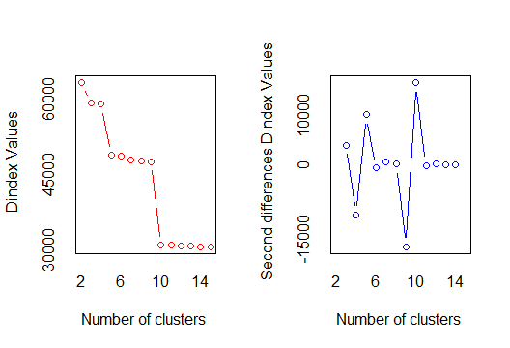

***So, the optimum number of clusters in hierarchial clustering is 10.***

distm <- dist(normalizing,method="euclidean")

hicl <- hclust(distm,method="complete")

plot(hicl)

plot(hicl,hang=-1)

trm <- cutree(hicl,k=10)

rect.hclust(hicl,k=10,border="red")

mat <- as.matrix(trm)

final <- data.frame(airlines,mat)

View(final)

aggregate(airlines[,-1],by=list(final$mat),mean)

|  |
| --- |
| Group.1 Balance Qual_miles cc1_miles cc2_miles cc3_miles Bonus_miles Bonus_trans  1 1 62801.90 99.91039 1.955878 1.000000 1.000822 13688.18 10.22828  2 2 68876.58 23.25581 1.139535 2.348837 1.000000 14689.84 17.53488  3 3 158977.20 186.05419 3.812808 1.000000 1.000000 59920.20 27.49261  4 4 153910.31 789.64444 2.022222 1.000000 1.000000 31835.36 29.42222  5 5 138061.40 78.80000 3.466667 1.000000 4.066667 93927.87 28.06667  6 6 973710.31 746.61538 2.538462 1.000000 1.000000 29401.08 16.61538  7 7 517178.83 85.33333 4.666667 1.000000 1.000000 172401.00 25.83333  8 8 102951.00 8275.86667 2.266667 1.000000 1.000000 17568.40 12.66667  9 9 106673.00 694.00000 2.500000 1.000000 1.000000 76325.00 75.50000  10 10 157326.00 0.00000 2.500000 1.000000 1.000000 54943.50 63.00000  Flight_miles_12mo Flight_trans_12 Days_since_enroll Award?  1 237.9921 0.7111537 4053.266 0.3384489  2 582.6279 2.2093023 3968.930 0.3953488  3 2188.7537 7.2118227 4972.266 0.7339901  4 8133.3778 21.0000000 4354.489 0.7777778  5 506.6667 1.6000000 4613.867 0.5333333  6 1576.3846 6.6153846 6972.846 0.8461538  7 1551.2500 4.3333333 5337.167 1.0000000  8 627.3333 2.3333333 4737.467 0.6666667  9 26458.5000 49.0000000 2602.000 1.0000000  10 13461.5000 49.5000000 1798.500 1.0000000 |
|  |
| |  | | --- | | > | |

***Kmeans clustering***

NbClust::NbClust(airlines, diss = NULL,distance = "euclidean",min.nc = 2,max.nc = 15,method = "kmeans")

* Among all indices:

* 8 proposed 2 as the best number of clusters

* 5 proposed 3 as the best number of clusters

* 1 proposed 4 as the best number of clusters

* 1 proposed 7 as the best number of clusters

* 1 proposed 8 as the best number of clusters

* 6 proposed 9 as the best number of clusters

* 1 proposed 11 as the best number of clusters

* 1 proposed 15 as the best number of clusters

***** Conclusion *****

* According to the majority rule, the best number of clusters is 2

*******************************************************************

$All.index

KL CH Hartigan CCC Scott Marriot TrCovW TraceW

2 2.1348 4248.312 3041.9622 -9.0477 25713.43 6.627963e+83 2.936881e+25 2.082880e+13

3 1.9582 5260.434 2260.1001 -29.6499 28552.26 7.332695e+83 8.387133e+24 1.182741e+13

4 2.3858 6242.261 1229.3903 -96.9370 30998.47 7.071005e+83 2.959888e+24 7.554600e+12

5 1.8166 6428.143 810.8860 -160.1186 32716.70 7.189518e+83 1.591895e+24 5.776871e+12

6 2.5385 6347.167 392.4537 -215.3521 33941.71 7.621243e+83 1.026161e+24 4.801950e+12

7 0.9529 5873.105 415.6183 -282.0696 35174.50 7.621444e+83 9.179767e+23 4.372224e+12

8 0.3162 5616.170 1453.4728 -276.0515 35874.60 8.355825e+83 7.382862e+23 3.959943e+12

9 4.3903 6883.779 409.0206 -246.1990 37860.01 6.436912e+83 3.509078e+23 2.902785e+12

10 1.7365 6789.918 268.1347 -239.3372 38941.26 6.064125e+83 2.961910e+23 2.632884e+12

11 0.6938 6546.866 375.2029 -235.6933 39818.71 5.891983e+83 2.574870e+23 2.467053e+12

12 1.4823 6544.118 278.9803 -229.0171 40379.39 6.094643e+83 2.106991e+23 2.254904e+12

13 1.8222 6440.156 177.0041 -224.5410 40920.90 6.246896e+83 1.826082e+23 2.107441e+12

14 0.4537 6220.800 347.7495 -222.5100 41929.20 5.630292e+83 1.705727e+23 2.017836e+12

15 3.3853 6303.794 134.1188 -215.8739 42574.40 5.500333e+83 1.423011e+23 1.855883e+12

Friedman Rubin Cindex DB Silhouette Duda Pseudot2 Beale Ratkowsky Ball

2 202.8858 3.1635 0.0368 0.8910 0.7420 0.9581 139.7506 0.3569 0.1442 1.041440e+13

3 207.7329 5.5710 0.0300 0.7815 0.6305 1.1009 -273.4195 -0.7482 0.1591 3.942470e+12

4 213.4429 8.7220 0.0308 0.7230 0.5896 1.1457 -436.0796 -1.0381 0.1472 1.888650e+12

5 218.9354 11.4060 0.0264 0.7923 0.5203 1.0557 -137.1312 -0.4308 0.1398 1.155374e+12

6 224.5547 13.7217 0.0242 0.8682 0.4771 1.1963 -134.7233 -1.3376 0.1342 8.003249e+11

7 226.3524 15.0703 0.0215 0.9116 0.4709 1.6041 -239.1282 -3.0692 0.1398 6.246034e+11

8 229.6094 16.6394 0.0194 0.9133 0.4361 1.7143 -206.2449 -3.3926 0.1322 4.949929e+11

9 244.4330 22.6992 0.0324 0.8654 0.4371 1.3143 -81.3124 -1.9399 0.1255 3.225316e+11

10 247.0674 25.0261 0.0308 0.8873 0.4481 1.9341 -516.2925 -3.9261 0.1245 2.632884e+11

11 251.6495 26.7083 0.0288 0.8891 0.4554 2.0749 -377.1449 -4.2099 0.1217 2.242775e+11

12 258.2888 29.2211 0.0262 0.8963 0.4189 1.7289 -93.1700 -3.4255 0.1176 1.879087e+11

13 263.5133 31.2658 0.0246 0.8928 0.3947 1.8758 -176.4870 -3.7950 0.1135 1.621109e+11

14 265.3764 32.6542 0.0234 0.8732 0.3965 2.0630 -361.7224 -4.1902 0.1147 1.441312e+11

15 272.2156 35.5038 0.0229 0.8818 0.3956 1.7402 -137.3865 -3.4517 0.1108 1.237256e+11

Ptbiserial Frey McClain Dunn Hubert SDindex Dindex SDbw

2 0.6725 6.0339 0.0365 0.0032 0 4e-04 48029.74 2.0920

3 0.5698 3.7483 0.1221 0.0010 0 5e-04 36646.32 2.4182

4 0.5238 3.5177 0.1768 0.0011 0 4e-04 31365.97 2.0742

5 0.4544 2.7976 0.2775 0.0009 0 4e-04 26431.56 1.7395

6 0.4104 1.7224 0.3605 0.0009 0 3e-04 23446.59 1.4978

7 0.3903 2.7393 0.3995 0.0007 0 3e-04 21863.81 1.3506

8 0.3562 0.9700 0.4837 0.0009 0 3e-04 20125.32 1.2057

9 0.3552 0.6850 0.4849 0.0015 0 3e-04 19343.79 0.8929

10 0.3528 1.3331 0.4828 0.0011 0 3e-04 18361.57 0.8176

11 0.3434 2.9388 0.4993 0.0014 0 2e-04 17508.92 0.7652

12 0.3092 3.0687 0.6093 0.0007 0 3e-04 16275.62 0.7105

13 0.2846 1.4379 0.7125 0.0010 0 3e-04 15440.01 0.6520

14 0.2760 0.2860 0.7420 0.0006 0 3e-04 14927.65 0.6111

15 0.2757 1.0260 0.7340 0.0008 0 3e-04 14456.94 0.5583

$All.CriticalValues

CritValue_Duda CritValue_PseudoT2 Fvalue_Beale

2 0.9261 255.0291 0.9778

3 0.9244 244.1095 1.0000

4 0.9231 285.6241 1.0000

5 0.9088 260.5330 1.0000

6 0.8943 97.0423 1.0000

7 0.8917 77.0958 1.0000

8 0.8796 67.7466 1.0000

9 0.8443 62.7058 1.0000

10 0.8625 170.4606 1.0000

11 0.8595 119.0248 1.0000

12 0.8584 36.4532 1.0000

13 0.8615 60.7652 1.0000

14 0.8660 108.6020 1.0000

15 0.8478 57.9702 1.0000

$Best.nc

KL CH Hartigan CCC Scott Marriot TrCovW

Number_clusters 9.0000 9.000 9.000 2.0000 3.000 9.000000e+00 3.000000e+00

Value_Index 4.3903 6883.779 1044.452 -9.0477 2838.829 1.546126e+83 2.098168e+25

TraceW Friedman Rubin Cindex DB Silhouette Duda PseudoT2 Beale

Number_clusters 3.000000e+00 9.0000 9.0000 8.0000 4.000 2.000 2.0000 2.0000 2.0000

Value_Index 4.728574e+12 14.8236 -3.7329 0.0194 0.723 0.742 0.9581 139.7506 0.3569

Ratkowsky Ball PtBiserial Frey McClain Dunn Hubert SDindex Dindex

Number_clusters 3.0000 3.000000e+00 2.0000 7.0000 2.0000 2.0000 0 11.0000 0

Value_Index 0.1591 6.471928e+12 0.6725 2.7393 0.0365 0.0032 0 0.0002 0

SDbw

Number_clusters 15.0000

Value_Index 0.5583

$Best.partition

[1] 1 1 1 1 1 1 1 1 2 1 1 1 1 1 1 1 1 1 1 1 1 1 1 1 2 1 1 1 1 1 1 1 2 1 1 1 1 1 1 1 1 1 1 2

[45] 1 2 1 1 1 1 1 1 1 1 1 1 1 1 1 1 1 1 1 2 1 1 1 1 2 1 1 2 2 1 1 1 1 1 1 1 1 1 1 1 1 1 1 2

[89] 1 1 1 1 1 1 2 1 1 1 1 1 1 1 1 1 1 1 1 1 1 1 1 2 1 1 2 1 1 2 1 1 1 2 1 1 1 1 2 2 1 1 1 1

[133] 1 1 1 2 1 1 1 1 1 1 1 1 1 1 1 1 1 1 1 2 2 1 1 2 2 1 2 1 1 1 1 1 1 1 1 2 2 1 1 1 2 1 1 2

[177] 1 1 1 1 1 1 1 1 1 1 2 2 2 1 1 1 2 1 1 1 1 1 1 1 1 1 1 1 1 1 1 1 1 1 2 1 2 1 1 1 1 1 2 1

[221] 2 2 1 1 2 1 1 1 1 1 1 1 1 1 1 1 1 2 1 1 1 1 2 1 2 1 1 1 1 1 1 1 1 1 1 2 2 1 2 2 1 1 1 1

[265] 1 1 1 1 1 1 1 1 1 1 1 2 1 1 1 1 1 1 2 1 1 1 1 1 1 1 2 1 2 1 1 1 1 2 1 1 1 1 2 2 1 1 1 2

[309] 1 1 1 1 1 2 1 1 1 1 2 1 1 2 1 2 1 2 1 2 1 1 1 1 1 1 1 2 1 1 1 1 1 1 1 1 1 1 1 2 1 1 1 1

[353] 2 1 1 1 1 2 1 1 1 1 2 1 1 1 1 1 1 1 1 1 1 1 1 1 1 1 1 1 2 1 1 2 1 1 1 1 2 1 1 1 1 1 1 1

[397] 1 1 1 1 2 1 1 1 2 1 1 2 1 1 2 1 1 2 1 1 1 1 1 2 2 1 2 1 1 1 1 2 1 1 2 1 1 1 1 1 1 2 1 1

[441] 1 1 1 1 2 1 2 1 2 1 1 1 1 2 1 1 1 1 1 1 1 1 1 1 2 2 2 2 1 1 1 2 1 1 1 1 2 1 2 1 1 2 1 1

[485] 1 1 1 1 2 1 1 1 1 1 1 1 1 1 1 1 2 1 1 2 1 1 1 1 1 1 2 1 1 1 1 2 1 1 1 1 1 2 1 1 1 1 1 1

[529] 1 1 2 1 1 1 2 1 1 1 1 1 1 1 1 1 1 2 1 1 1 2 1 1 1 1 1 1 1 2 1 1 1 2 1 1 1 1 1 1 1 1 1 1

[573] 1 1 1 1 1 1 1 1 1 1 1 1 1 1 1 1 1 1 1 1 1 1 1 1 1 1 1 2 1 1 1 1 1 1 1 1 2 1 1 1 1 1 1 1

[617] 1 1 2 1 1 1 1 1 2 1 1 1 1 2 2 1 1 1 1 1 1 1 1 1 1 1 1 1 1 1 1 1 1 2 1 1 2 1 1 1 1 1 2 1

[661] 1 1 1 1 1 1 1 1 1 2 1 1 1 1 1 1 1 1 2 1 1 1 2 2 1 1 1 1 1 1 1 1 2 2 1 1 1 2 1 1 1 2 2 1

[705] 2 1 1 1 2 1 1 1 1 1 1 1 1 1 1 1 1 1 1 2 1 1 1 1 1 1 1 1 1 1 1 1 1 1 1 1 1 1 1 2 1 2 1 1

[749] 1 1 2 1 1 1 2 1 2 1 1 1 1 1 1 1 1 2 1 1 1 1 1 2 1 1 1 1 1 2 1 1 1 2 1 1 1 1 1 2 1 1 1 1

[793] 1 1 1 1 1 1 2 1 1 1 1 1 1 1 1 1 1 1 1 1 1 1 1 1 1 1 1 1 2 1 2 2 1 1 1 1 1 1 1 1 2 1 1 1

[837] 1 1 1 1 1 1 1 1 1 1 1 1 1 1 1 1 1 1 1 1 1 1 1 1 1 2 1 1 1 1 1 1 2 2 1 1 1 1 1 1 1 1 1 1

[881] 2 2 1 1 1 1 1 1 2 1 1 1 1 1 1 1 2 1 1 1 1 1 1 1 1 2 1 1 1 1 1 2 1 1 2 1 1 2 2 1 1 1 2 1

[925] 1 1 1 1 1 1 1 1 2 1 1 1 1 1 1 1 1 1 1 1 1 1 1 2 1 1 1 1 1 1 1 1 1 1 1 1 1 1 1 2 1 1 1 1

[969] 1 1 1 1 1 1 1 1 1 1 1 1 1 1 1 1 2 1 1 1 1 1 1 1 1 1 1 1 1 2 2 2

[ reached getOption("max.print") -- omitted 2999 entries ]

Warning message:

did not converge in 10 iterations

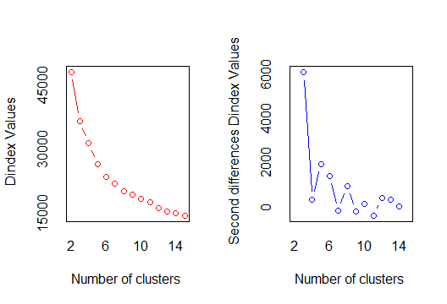

***So, the optimum number of clustering in k means is 2.***